Aranda Primary School P&C Association
Minutes
7.30am, 5 December 2018

- Welcome and Attendance:
Petra Cole (President), Phil Gray (Principal), Alyssa Nevin (Vice-President), Kath Kulhanek (Treasurer), Heather Clark (Secretary), Jim Gilchrist (Public Officer), Paula Banks (Class Reps), Lucy Coffey (Uniform Shop), Jason McCrae (Canteen), Holly Brocklebank, Scott Pearce, Bob Bannister, Ann Palmer (Book Club), Karen Ingram Hall (Communications)

- Apologies:
Nil recorded.

- Confirmation of minutes from the last meeting:
The minutes of the previous meeting were confirmed by Kath and seconded by Jim.

- Matters arising from the minutes of the last meeting:
Nil.

- Reports:

5.1 Principal:
– Staff are very busy with reports and concert preparations. Reports will be distributed at the end of Week 9;
– Phil has received some positive feedback on his recent community message video and it is already at 156 ‘views’. There are a number of benefits of preparing a video (rather than having a face-to-face meeting) including the reach is far greater. Other videos are planned including one focussed on teacher and learning for early 2019;
– Plans were shared for the planned ground artwork at the school which will include a chessboard, activity track, hopscotch and snakes and ladders. The total cost is $11,000, half of which is covered by the P&C;
– Phil and Scott expressed their thanks to the P&C for the donation of two extra bikes and let the Committee know that a single loop, multi-purpose track is planned to circuit the school. A working bee on 15 December will start work on the track, with the hope it will be completed by the time school returns in early 2019.

5.2 President:
– A new, industrial sized BBQ has been ordered (assisted with a contribution of $1000 from Afters), however it does need to be constructed once it’s received;
– Concert food options have been added to Flexischools for ordering – big thanks to Canteen staff for their help. Food will need to be picked up between 5–5.45pm, before the concert starts at 6pm;
– Welcome Picnic 2019: the Committee discussed the scheduling of this event for 2019 and decided that the focus should be on the 50th anniversary and the whole of school event planned for Tuesday 12 March (Week 6). Other anniversary events include: whole school assembly and burial of new time capsule, tours for former students and teachers in Term 2 and the fete;
– A meeting of the fete planning committee is proposed for January.
5.3 Treasurer:
Written report – see Appendix A.
– The current balance is $32,804 (following the donation of $7000 to the school for the ground artwork and purchase of the printer);
– Cherry drive: 41 boxes were ordered (a great result & similar to last year).
5.4 ACT Council of P&C Associations:
Nil to report.
5.5 Public Officer:
– Reminder that the audit of the P&C accounts needs to be completed as a priority.
Action: Kath to arrange audit.
5.6 Board:
Nil to report.
5.7 Music and Arts Program:
Nil to report.
5.8 Fundraising & Events:
Nil to report.
5.9 Canteen:
– Planning to hold a special lunch in the last week of school and would like to use the BBQ for this;
– The microwave has died and a new one will need to be purchased in January once its confirmed whether it is Canteen or Afters owned;
– The Canteen won an award from Nutrition Australia–a notice will be included in the school newsletter;
– Lunch order numbers are looking very healthy and have increased, which is pleasing.
5.10 Uniform Shop:
Written report – see Appendix B
– Are planning to open on Monday 4 February (first day of school for Kindergarten and new students) and possibly on Friday 1st;
– Good sales were made on the Kindy night with between $400-$500 worth of purchases;
– Volunteer numbers have dropped so will be putting a call out for more in the new year;
– PayPal/permanent card payment machine is very close to being set up.
5.11 Class Representatives:
Nil to report.
5.12 Book Club:
– Books to the value of $600 have been ordered through the awards generated by the book club program;
– Another order for $3000 has been placed and volunteers are organised to assist with the sorting of orders once they arrive.
5.13 School banking:
Nil to report.

- Other business:
– Suggestion to use the 3D printer to make bag tags as a fundraiser/fun gift;
– General discussion around the end of year P&C event and suggestion to try something different for next year.

Action: Kath to speak with Scott about 3D printed tags.

- Date of next meeting:
Wednesday 20 February 2019

Appendix A – Treasurer’s Report

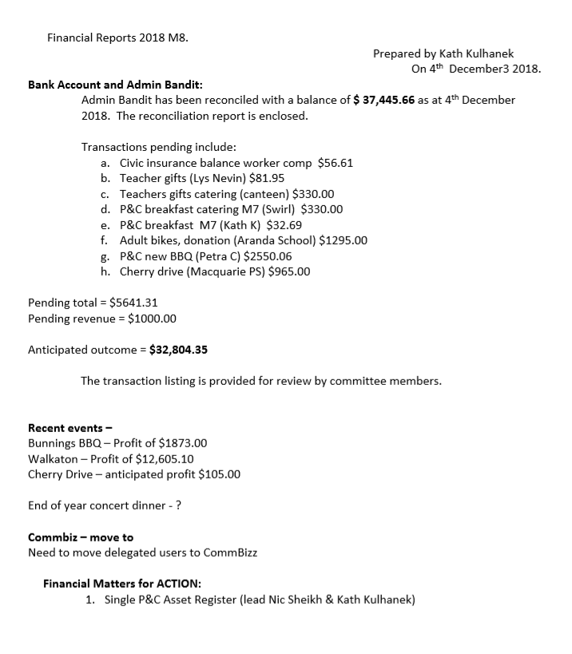

Appendix B – Uniform Shop Report

Provided by Lucy Coffey & Diana Godwin:

Aranda Uniform Shop

Notes for P&C meeting on 5th December 2018

Bank Account 1/7/18 – 1/12/18
- Opening balance $9,736.42
- Closing balance $11,647.72

- Total receipts $6,402.48
- Total payments $4,491.18
= $1,911.30 profit

Uniform Shop update– Term 4, 2018

- Opening the first day of term in 2019 – Monday 4th Feb 08:30 – 09:30 This is being advertised in the remaining newsletters, and via class parent reps and word of mouth

- Volunteers: Small but committed group of volunteers, however numbers low – request for more volunteers also in the newsletters, and via class parent reps and word of mouth

- Kindy night: We attended and presented our shop. Lots of interest. Took approx. $500 on the night in school uniform purchases!

- Preschool: 75 preschool hats ordered for Alex for 2019 preschoolers

- Paypal: a year on, and the paypal machine is yet to be up and running due to a myriad of complexities involving bank accounts, authorisations, mobile phone and internet access, and getting the right deal for data. We need a final push to get it over the line for use in 2019.

Lucy Coffey & Diana Godwin
Uniform Shop Coordinators

