Aranda Primary School P&C Association
Minutes
6.30pm, 28 March 2018

- Welcome and Attendance:
Petra Cole (President), Kath Kulhanek (Treasurer), Heather Clark (Secretary), Jim Gilchrist (Public Officer), Paula Banks (Class Reps), Lucy Coffey (Uniform Shop), Troy Heland (School Board), Laura King (Canteen).

- Apologies:
Phil Gray (Principal), Lisa Kingham (Deputy Principal), Holly Brocklebank (Vice-President), Jason McCrae (Uniform Shop), Ilona Horvath, Alyssa Nevin, Xiaoyan Lu (P&C Association).

- Confirmation of minutes from the last meeting:
The minutes of the previous meeting were confirmed by Kath and seconded by Paula.

- Matters arising from the minutes of the last meeting:
Nil to report.

- Reports:

5.1 Principal (via email):
– Phil is very pleased to see how much content is being added to Seesaw and the parent and teacher engagement. By the end of the year this will amount to a very comprehensive portfolio.
– Works in the Hall are progressing well however the retractable seating won’t be installed until Term 2.
5.2 President:
– The 2019 Fete Committee has already convened their first meeting. The Committee members are Karolyn, Petra, Kath, Jim and Alyssa. They are booking in major things and discussing the incorporation of new ideas.
– Big thanks to Paula for organising teacher and staff gifts post-camp. It was suggested and endorsed by the Committee that the organisation of gifts for camp and Teacher Appreciation Day would be the responsibility of the Committee Vice-President.

Action: Vice-President to organise gifts for Teacher & Staff Appreciation Day in October.
5.3 Treasurer:
Written report – see Appendix A.
– The School will be putting together a prioritised wishlist of items for presentation to the P&C.
– P&C supported the purchase of new equipment for the sports carnival.
Action: School wishlist to be discussed at next meeting.
5.4 ACT Council of P&C Associations:
Nil to report.
5.5 Public Officer:
– Paperwork for constitutional change is ready to be sent out. The plan is to distribute the notice via the class reps, to all sub-committee members and via the newsletter.
– Quiz night plans are progressing well. Its likely to be held at the Labor Club again, possibly in July or August. Tickets will be sold for tables as a whole and there will be a raffle and coin toss games.
5.6 Board:
– Still waiting for some parent nominations to complete the membership.
– Voluntary contributions letter has been sent out and reminder letters are planned for each term.
– The timing of the Board and P&C meetings was discussed and it was agreed they work well as they are.
5.7 Music and Arts Program:
Nil to report.
5.8 Fundraising & Events:
– The Committee discussed the bag tag promotion/fundraiser and agreed it was a great idea.
– Big thanks to Kath for organising the Family Picnic. It was a great success with at least 43 families, good food (thanks, Canteen!), and lots of fun. It was decided to make this an annual event, holding it around the same time each year and with planning commencing in Term 4.
– The clean up under the house has been pushed back until May. Kath will follow up with the school.
– Fete report – see above.
Action: Kath to talk with school about clean up under the house working bee.
5.9 Canteen:
Written report – see Appendix B
– The Committee discussed the ongoing issues with the canteen freezer and approved the purchase of a new one.
– Bank account signatories still need to be changed.
5.10 Uniform Shop:
Written report – see Appendix C
– Approval was sought and gained to increase the price of the summer school dress.
– Plans are progressing to allow preschool parents to order uniforms in advance for the kindie year as well as open up the shop on the first day of school.
5.11 Class Representatives:
Written report – see Appendix D
5.12 SOCS:
Nil to report.
5.13 School banking:
Nil to report.

- Governance:
– Petra has reached out to all sub-committees regarding the proposed move to a centralised, cloud-based online platform for managing the records for the P&C.
– An email domain has been purchased with all P&C emails to be changed to @arandapandc.com.
– A night will be planned so that everyone can get together to be taken through the new site, but at the moment communication is happening individually to seek feedback for the new structure.
– The hope is that the website will assist with inter-committee communications as well as formalise and increase the transparency of all P&C record keeping.
- Other business:
– The Committee discussed the idea of including a newsletter notice after each meeting summarising any key discussions – all agreed it was a good idea.
Action: Newsletter summary to be drafted following each meeting.

- Date of next meeting:
6.30pm, 16 May 2018
Appendix A – Treasurer’s Report

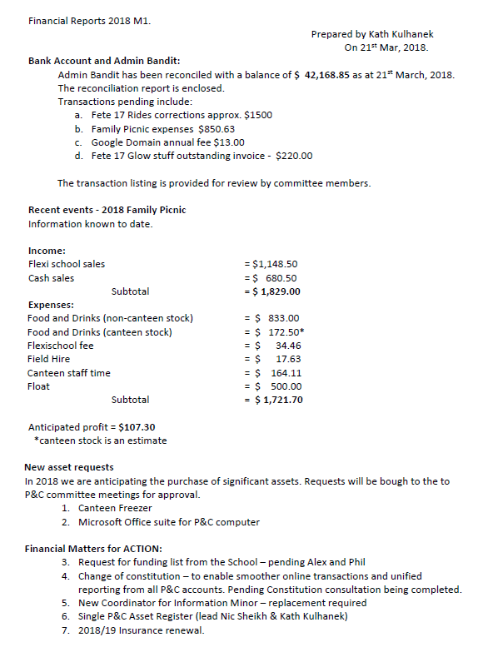

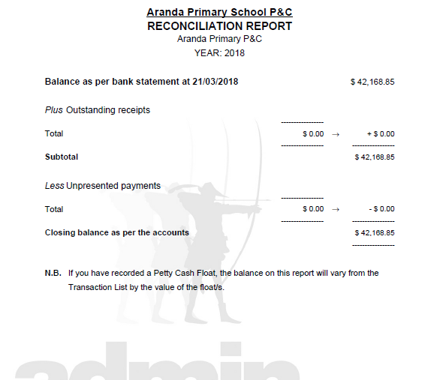

Appendix B – Canteen Report

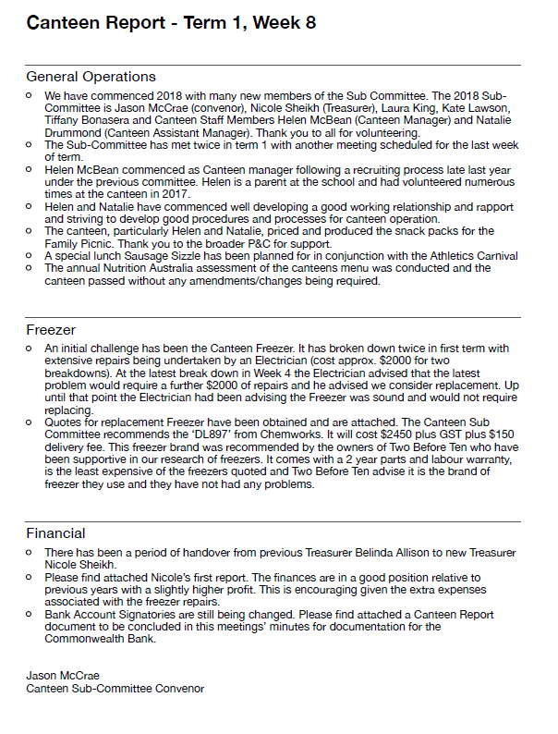

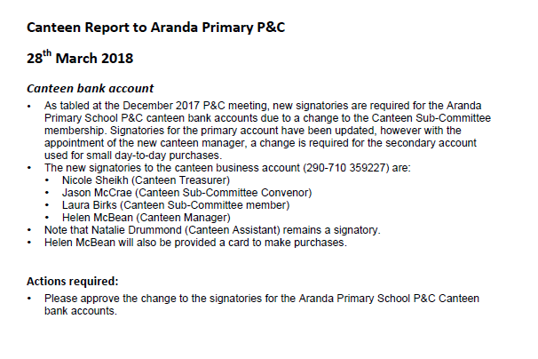

Appendix C – Uniform Shop Report

Report for P&C meeting on 28 March 2018

Bank Account
Bank balance at 21/3/18 is $12,249.85

 | Financial year to date
Receipts | $20,860.46
Expenses | $24,798.74
Balance | -$3,938.28

Term 1 2018
- Staff update: we have three new volunteers, but have lost three volunteers, two of whom were very experienced. We plan to advertise again in the newsletter, and through parent class reps now we’re getting settled into the new school year
- Electronic payments: setting up the Paypal machine (bought by the P&C for use at the fetes) for use in the uniform shop is more involved than previously thought, however we are slowly progressing. Due to the lengthy process, I have been using a Square card reader I purchased for the fete. But it is set up with the P&C bank account, not the uniform shop bank account. I am trying to get this resolved, but again, it is complicated. We have been taking card payments each week so far this year. Kath – are you and Felix happy for us to continue to use the Square card reader (and therefore to transfer amounts between bank accounts) until the Paypal machine is set up?
- Opening the Friday before Term 1 of 2018: we went ahead and opened up the Friday before Term 1 started. It was successful, and we had a very busy first few weeks! Alex Kingham asked if we were going to be open on the Monday for the new kindergarten students. We weren’t able to this year, but could consider it for next year.
- Price increase request: We’re recommending an increase to the price of the summer school dress from $40 to $45 to cover costs and provide a small mark-up. This price is still below the selling price in commercial outlets.

Lucy Coffey & Diana Godwin
Uniform Shop Coordinators

Felix Andrews
Uniform Shop Treasurer
Appendix D – Class Representatives Report

Provided by Paula Banks:

Class parent representatives:

- Class parent reps found for all 27 classes, cleared by Phil and given instructions and guidelines to follow.
- Class teachers collected contact details during interviews and class lists were passed on to the relevant rep.
- Class lists were not available for preschool (due to interviews last year) and some 5/6 classes (problem unknown). Even in Week 7, some reps were still working on completing their class lists.
- Reps have already distributed a wide variety of information, and have helped the P&C to promote the family picnic and find canteen volunteers.

