**Aranda Primary School P&C Association**

**Annual General Meeting Minutes**

**6pm, Resource Centre, 18 September 2019**

1. **Welcome and Attendance:**   
     
   Petra Cole (President), Phil Gray (Principal), Alyssa Nevin (Vice-President), Kath Kulhanek (Treasurer), Heather Clark (Secretary), Jim Gilchrist (Public Officer), Paula Banks (School Reps), Wendy Robertson, Penny McKenzie, Mark, Joel Dalton, Troy Heland (School Board).

1. **Apologies:**  
   Lucy Coffey, Jason McCrae, Kate Burmester.
2. **Confirmation of minutes from the last AGM:**   
     
   The minutes from the 2018 meeting were confirmed by Jim and seconded by Kath.
3. **Reports for AGM:**

*4.1 Principal:*Written report – See Appendix A.

– School review: went very well, students, staff, P&C and the Board were all interviewed. The report has been loaded onto the school website and can be viewed there. These reviews are undertaken every five years and the school received many commendations including one for setting a strong culture;

– Just 50 Words: also went very well with a great presentation from local author Jack Heath and great entries from the kids;

– Reminder that Grandfriend’s Day is on Friday.

*4.2 President:*Written report – see Appendix B.

– Would like to extend a very big thanks to all P&C supporters and sub-committees;

– This year had many big events and achievements including the Walkathon, the 50th Birthday BBQ, teachers’ gifts, the purchase of a 3D scanner and new BBQ and a great result for the election day BBQ and cake stall in May.

*4.3 Treasurer:* Written report – see Appendix C.

– The P&C is in a healthy financial position with $18,000 in cash reserves;

– The new bidding schedule from school staff is working well and the P&C provided close to $22,000 to the school for initiatives and projects;

– Unfortunately, due to a delay in submitting the Association’s financial statements the P&C has been de-registered. This has arisen due to the P&C financial year dates not aligning with the standard dates. Four news submissions are required for the dates 9 July to 8 July the following year. Once these have been submitted and the books audited the P&C can register again.

– The Treasurer proposes that the P&C constitution be changed to align with the standard financial year, that is 1 July – 30 June. This was moved by Alyssa and seconded by Karen. A notice for the newsletter has been drafted and will be included in the next edition.

*4.4 Public Officer:*

– Is assisting the Treasurer with report lodging;

– Will also chase up Committee forms.

*4.5 Music and Arts Program:*  
Written report – see Appendix D.

*4.6 Canteen:*  
Written report – see Appendix E.

– The roller door needs replacing with quotes received indicating that replacement will be expensive (around $12,000). Other options are being explored;

– The Treasurer has resigned and the Committee is currently looking for another.

*4.7 Uniform Shop:*  
Written report – see Appendix F.

– All going very well – big thanks to Lucy and other Uniform Shop staff;

– $5,000 has been donated to the P&C

*4.8 Book Club:*  
Written report – see Appendix G.

– The Club is receiving a pleasing number of orders and has made close to $700 in rewards for the school.

1. **Election of Office Bearers**

The following office bearers were confirmed at the meeting:

|  |  |
| --- | --- |
| President | Petrina (Petra) Cole |
| Vice President | Joel Dalton |
| Treasurer | VACANT |
| Secretary | Wendy Robertson |
| Public Officer | Jim Gilchrist |

Other nominated supporting positions include:

Class representatives: Paula Banks

Communications: Karina Henman

1. **Other business**

Nil.

1. **Date of next meeting:**  
   TBC

**Appendix A – Principal’s Report**

**Aranda P&C – Principal’s Report 18.9.2019**

**School Review:**

Aranda School completed the school review process on Friday, August 16.

The review panel spent 4 days in the school and spoke to parents, children and staff during their time with us. I appreciated the comprehensive and robust nature of the review. The ACT Education Directorate will post the report on our school website soon.

The findings from the review panel were very positive. One of the commendations that pleased me the most was that the panel considered the school culture to support learning was exemplary. I am grateful that the panel shared some recommendations with us that will help our community to develop a meaningful new school plan in the coming months.

Congratulations to the entire Aranda School community for what we have achieved not just during school review but also over the five-year term of the last school plan. I would particularly like to thank Lisa Kingham, Scott Pearce and Alex Wrigley for the leadership of the review process.

**Just 50 Words:**

We recently celebrated our love of writing at our Just 50 Words assembly. Every student at the school participated - Congratulations to all of them. Thanks to Heather (P&C) and Troy (School Board) for presenting prizes on the day. I don’t envy Patrick from Canberra High who does a brilliant job to judge the competition every year. I thought Jack Heath, our local author and guest speaker delivered a fantastic speech to an enthralled audience.

Phil Gray

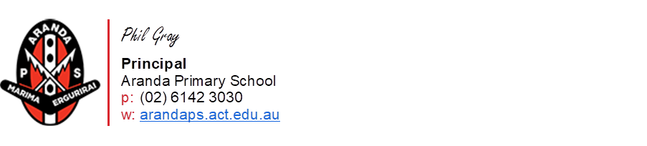

**Appendix B – President’s Report**

**AGM President Report – 18 September 2019**

* Another wonderful year of P&C activities and support. Sub committees continue to be extremely successful and the service they offer Aranda families is invaluable.
* A big thank you to all the wonderful volunteers who have supported the P&C throughout the year. Too many to list every single one but a shout out to Lys as Vice President, Jim as Public Officer, Kath as Treasurer, Heather as Secretary, Paula as Class reps and Karen as Communication Officer.
* It has been a pleasure working with and supporting the school.
* Some major achievements in the last year include:
* Successful walkathon
* Contributed to the 50 year BBQ picnic at Stromlo
* Planned for the 2019 fete (26 October). This has taken considerable attention this year as planning began in mid-2018.
* Able to assist the school with financial donations to achieve Just 50 Words, robotic purchases, playground art, teacher professional development, several new marques and more.
* Gifts for teacher who attended camps and teacher appreciation day for all staff.
* Ongoing strong relationship with Afters.
* Purchased a new industrial size BBQ for canteen and school events
* Assisted the school in the review process.
* Ran a cherry drive in Dec 2018.
* Coordinated ordering of dinner options for the 2018 end of year school concert.
* Book Club joined the P&C and is doing extremely well.
* Other efforts have centred on P&C committee renewal and encouraging new people to join. Many current members will transition out of their roles either at this meeting or next year. I plan to transition and hope to hand over to the new vice president over the next year, assuming I am re-elected. My goal would be to step down in 2020 AGM and concentrate on ongoing fetes and perhaps join the school board. I would still be an engaged P&C member.

Goals for 2019/2020

* Enjoy a wonderful fete – Term 4 2019
* Welcome new members to the P&C
* Welcome picnic Term 1 2020
* If agreed by the committee look at Trivia in Terms 2 or 3 and if agreed by school support Walkathon again in Term 3 or 4.

Prepared by - Petra Cole – President

**Appendix C – Treasurer’s Report**

[No written report received.]

**Appendix D – Music and Arts Program Report**

**AMA Annual Report, September 2019**

Prepared by Kate Burmester

* The AMA offerings have remained highly subscribed by Aranda families. Enrolments for 2019 continued to be at the high levels experienced last year and art has been over-subscribed again all year. We have continued to break-even financially this year, with no increase in fees for families.
  + Excitingly, we have also facilitated the return of two subjects that we have not been able to offer for some years now - dance and singing. The dance class is held at the illesso studio at the Aranda shops, providing students with a spacious place to learn, and not creating a demand for teaching staff to free up a room. We hope to move to offering our drama lessons in 2020 using the same model and to increase to two afternoons of dance next year.
  + We have run all art classes with classes of 16 students supported by having former art students (now in high school) working as assistants to Karen.
  + We decided to run just one recital series in 2019, rather than having mid-year and end-of-year shows. This takes some of the pressure off the committee and also avoids families having to juggle the recitals, particularly with other end of year commitments. We held our 2019 recitals last week, which included all but our drama and junior music classes.  As always it was an inspiring and rewarding night as the audience was awed by the confidence, competence and polish of our young performers. We will hold a junior music recital this Wednesday night for friends and families of Michael Sollis’s classes and Drama students will have a separate show-case in the latter part of term 4.
  + We have continued to have a fabulous array of talented tutors who enthusiastically impart their musical and artistic know-how to our students.
  + Coordination with the school and Afters has continued to be managed through open and timely communications.
  + We intend to again align our 2020 enrolment process with the Afters enrolment timeframes, with the aim to have as much of our placements sorted before the end of term 4. We will be coordinating with the school to work out appropriate room allocations to minimise the load on teachers’ rooms. We hope to start most lessons in Week 1, in alignment with Afters and school and, as always, work around parent-teacher interviews and other school commitments as required.
  + We again acknowledge Lisa Kingham’s ongoing helpful coordination throughout, the assistance of the front office team, and other Executive staff. We especially acknowledge and thank those teachers who generously share their teaching space in support of the program.
  + In closing, I would like to acknowledge our wonderful and dedicated committee who are highly responsive to families and tutor needs, juggling the demands of AMA amongst many other priorities to bring these fabulous opportunities to our children.

Thank you team!

**Appendix E – Canteen Report**

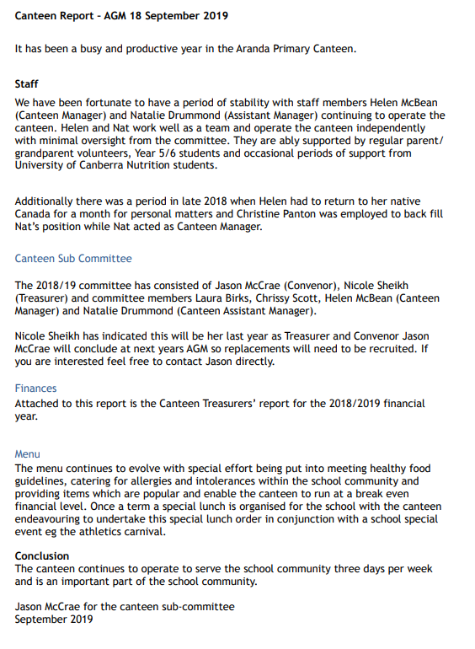

# Canteen treasurer’s report

# As at 9 July 2019 – End of financial year

## Finances

***Financial year total:***

|  |  |  |  |
| --- | --- | --- | --- |
|  | **10/07/2016 – 09/07/2017** | **10/07/2017 – 09/07/2018** | **Current year**  **10/07/2018 – 09/07/2019** |
| Income | 58,532 | 80,734 | 81,846 |
| Less: expenses | 57,873 | 83,362 | 78,821 |
| **Surplus** | **$659** | **-$2,628** | **$3,025** |

***Financial year by quarter:***

|  |  |  |  |
| --- | --- | --- | --- |
|  | **Income** | **Expenses** | **Surplus** |
| 10 July – Sept | 18,773 | 18,158 | 615 |
| Oct – Dec | 25,606 | 22,040 | 3,566 |
| Jan – Mar | 10,500 | 15,778 | -5,278 |
| Apr – 9 July | 26,967 | 22,845 | 4,122 |
| **Total** | **$81,846** | **$78,821** | **$3,025** |

**Note**: minor differences due to rounding

# Treasurer’s notes

* Financial position summarised above with the detailed report attached.
* The canteen made a profit of $3,025 for the year
* P&C and canteen treasurer are working together to update the details with the ATO and have an operating AUSkey. This will mean the correct people will have access to the required information and the staff super can be once again paid via the ATO Super Stream.
* While we are waiting for required access to ATO, the canteen treasurer is paying staff super directly to their nominated super funds. A summary of super paid for staff during the 2017-18 financial year has been provided to Helen and Nat to confirm this is being deposited into their super accounts.
* P&C treasurer has the file for the 2017/18 audit
* Nicole Sheikh is resigning as treasurer of the canteen at the end of the 2019 calendar year. Nicole will assist with transition over the next few months once a new treasurer is identified so the new treasurer can begin in February 2020.

**Appendix F – Uniform Shop Report**

Aranda Uniform Shop

Annual report for financial year ending 2019

Wednesday 18 September 2019

**Financial headlines**

Total sales: $19,089.36 (down 4%)  
Clothing purchases: $17,997.65 (down 16%)  
Operating profit of $1,091.71  
Closing balance of $10,828.13

Sales by payment method:

Cash: $8,047.40 (42%, down from 59%)  
Flexischools: $7,810.44 (41%, up from 36%)

Card: $2,502.11 (13%, up from 5%)

School: $730.20 (4%)

Please see the attached Uniform Shop Treasurer’s report for further details.

**What we did**

* Got the paypal machine up and running! Huge thanks to those involved along the way – particularly Lisa, Fiona, Cath, and Petra.
* Managed a change in Stock Manager, one of the key roles of the uniform shop, from Diana Godwin, with thanks, to Janaline Oh.
* Implemented changes to the stock management spreadsheet for more accurate recording of stock levels – many thanks to Janaline.
* Recruited three new volunteers. Welcome to Fiona, Katie, and Janaline. Said thanks and farewell to Lisa H, Rowena, and Jane
* Ran the Uniform Shop every Friday during school year with parent volunteers
* Attended the Kindy and new student night
* Attended P&C Meetings
* Donation to the school of $5,000
* Provision of raffle prizes (vouchers for free school uniforms) for the Fete
* Provision of special orders such as swimming caps, preschool hats, and ad hoc purchases by the Business Manager

**What we would like to do**

* Explore whether pre-schoolers can be put onto Flexischools to enable early ordering
* Add photos of uniform items onto Flexischools
* Update Flexischool item descriptions to comply with ACT Education department guidelines re gender neutrality
* Participate in moving Gmail and documents to new P&C website
* Make another donation to the school

Prepared for AGM on Wednesday 18th September 2019

Lucy Coffey, Janaline Oh (Uniform Shop Co-ordinators) and Felix Andrews (Treasurer)

P&C Sub-Committee Aranda Uniform Shop

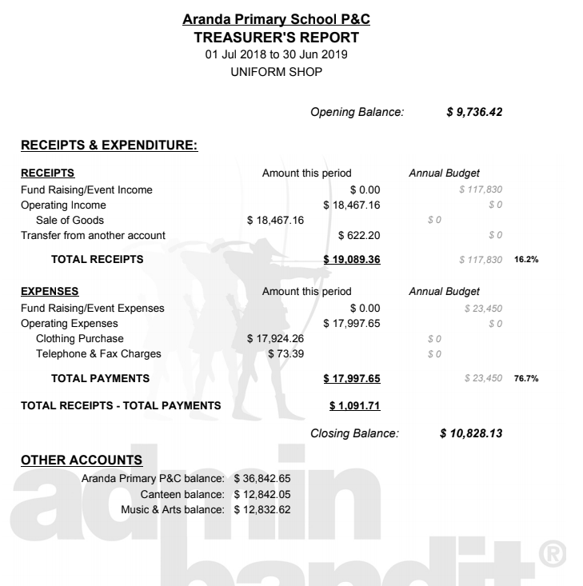

**Appendix G – Book Club Report**

**September 2019**

Prepared by – Ann Palmer

It has been a fantastic first 18 months for the Book Club at Aranda Primary School.

The Book Club was introduced in February 2018, with students offered the opportunity to order from one catalogue issue per term.

Orders grew through 2018, peaking in Term 4 (Issue 8, pre-Christmas) at $2998.00. The order for Term 2, 2019 (Issue 4) is the largest order so far, with a total of $3148.00 worth of books ordered.

The school earns 20% in Rewards on all Book Club orders. The rewards earned through the Book Club have been put to great use. The first reward order in November 2018 resulted in $608.24 of books donated to the school library on behalf of the Book Club.

As at May 2019, a further $2,068.56 in rewards had been redeemed by the school, with a further $680.21 available to use. Rewards were used to purchase:

*For the library:*

* a range of junior and senior fiction books and games
* teacher resource books K - 6

*For use in classrooms:*

* fine motor activities and games
* sets of work sheet protectors
* student stickers

Thank you to Executive Teacher Jenny Coen took on the role of rewards coordinator in 2019. And a big thank-you to all the volunteers who have helped out with distributing catalogues and sorting books – Natalie, Cleo, Susan and Nimali.