Aranda Primary School P&C Association
Minutes
6.30pm, 21 February 2018

- Welcome and Attendance:
Phil Gray (Principal), Holly Brocklebank (Vice-President), Kath Kulhanek (Treasurer), Heather Clark (Secretary), Lisa Kingham (Deputy Principal), Paula Banks (Class Reps), Jason Allison (Canteen), Troy Heland (School Board), Ilona Horvath, Alyssa Nevin, Teresa McFarlane.

- Apologies:
Petra Cole (President), Jim Gilchrist (Public Officer), Don Lowe, Lucy Coffey, Xiaoyan Lu.

- Confirmation of minutes from the last meeting:
The minutes of the previous meeting were confirmed by Ilona and seconded by Paula.

- Matters arising from the minutes of the last meeting:
Nil to report.

- Reports:

5.1 Principal:
– Good start to the year although the school is still a little of a ‘building zone’. The School Hall is still out of action and the new chairs won’t be in place until the end of Term 1, possibly the beginning of the next;
– Phil is thrilled with the new transportable, with both kids and teachers responding very well to the new space. There is terracing and water harvesting in place, and the garden and grounds will be re-established. The only thing missing is covered walkways: a possible focus for P&C fundraising efforts?;
– A number of new staff have joined the school this year including: Lauren, Nicole, John and Caroline, and a there are also a number of new teachers joining the school executive group: Lisa, James and Scott;
– The kindergartners have also made a very settled start to the year, and all of these things combined has meant a very positive start to the year for all the teachers and staff as well;
– January was spent in training, first aid included;
– Teachers and staff are keen for a walkathon again this year, possibly at the end of Term 3 (week 9 or 10). This won’t interfere with the end of year concert;
– On the school wishlist: 3D printer, expedition pack, STEM requests;
– Phil is not keen to join the current Coles supermarket school sports promotion. When the school has participated in past years they have been disappointed in the quality of the equipment that was supplied;
– The Committee discussed the pros and cons of a buddy bench, however the school feels that the ‘protective playground’ program the school encourages is adequate and that the bench or a similar designated area would not complement this;
– The school swimming carnival will be held at CISAC again with participation from competitive swimmers only. Government legislation makes it quite restrictive as to how carnivals can be organised;
– The Committee discussed voluntary contributions and the building/library fund arrangements. P&C member Teresa McFarlane offered her assistance with the drafting of the letter to parents and other communications strategy ideas – an offer welcomed by the school and Board.

Action: Phil to ask Alex to forward school requests to Kath for expenditure approval out of session.
Action: Teresa to be put in touch with the School Board via Phil.
5.2 President:
Written report – see Appendix A.
– ‘Fete 2019’ has been confirmed for Saturday 26 October – mark the date in your diaries;
– The Family Picnic will be held on Tuesday 13 March, after the Canberra Day long weekend. Pre-ordered food options are all organised with flexischool orders all set up. Estimating around 50 families will attend and volunteers are organised for collecting food and all communication plans in place (flier, newsletter, school reps notice etc.). The wet weather plan is to move to the multi-purpose court, otherwise it will be held across the road at the oval;
– Other P&C events for the year include: Quizmas in July (or August), walkathon, and clean-up-under-the-house. The growing of voluntary contributions will also be a particular focus.

Action: Ilona and Jim to commence planning for Quizmas in July (or an early Saturday in August).

5.3 Treasurer:
Written report – see Appendix B.
5.4 ACT Council of P&C Associations:
Nil to report.
5.5 Public Officer:
– Constitutional change is a priority.
5.6 Board:
– First meeting of the year will be held tomorrow.
5.7 Music and Arts Program:
Treasurer report – Appendix C.
– The Committee discussed the program recognising that it needs to be organised in partnership with the school.
Action: Insurance and structural arrangements to be confirmed.
5.8 Fundraising and events:
– See President’s report above: plans for the year are well advanced.
5.9 Canteen:
– The new sub-committee is yet to meet, however Jason Allison is the new Canteen Convenor and there is a new Treasurer as well;
– The new Canteen Manager has started;
– As reported above, the picnic is coming up and the Canteen will assist with arrangements as well as organising a special lunch on the Athletics Carnival day;
– There has been problems with the freezer however these are now fixed.
5.10 Uniform Shop:
Written report – see Appendix D.
5.11 Class Representatives:
– James Harrison has been a great help with setting up Google forms to collect parent information;
– The first message to parents will hopefully come out this week, with only four classes left to have reps volunteer;
– Preschool will be slow to start.
5.12 SOCS:
– Kath has offered to find out how program works since there is no longer a coordinator for the program and will check with the school about the businesses that are to be included;
5.13 School banking:
Nil to report.

- Other business:
– The Committee agreed to organise a gift and card to congratulate Lisa Kingham on her promotion;
– Simultaneous Storytime will be held in May with Ilona assisting in organisation;
– Records management: Kath has investigated ‘Google not-for-profits’ which uses the Google platform to manage all committee paperwork, website etc. Would need to purchase a domain name for a small ongoing fee.
– ‘Clean up under the house’: estimated to need around 25 volunteers, broken down into five teams (sorting, transport, tetris, support etc.), the clean up will be held over two weekends in April. A raffle will also be held to promote the event/working bee.

Action: Kath to look further into Google option for website and records management.
Action: Kath and Alex to organise ‘clean up under the house’ weekends.

- Date of next meeting:
6.30pm, Wednesday 28 March, 2018

Appendix A – President’s Report

21 February 2018

Hi guys

So bad news I can't make Wed evening. Holly could you chair the meeting please? Kath is kindly chatting about the picnic for me. My update is:

- Fete 2019 locked in as Saturday 26 October 2019. We could not secure rides for a Term 1 fete. Suggest fete committee (currently Kath, Jim, Karolyn, Alyssa and Petra) meet in Term 1 to chat about the larger roles.
- Met with Phil last week - Kath can discuss that and the forward plan if ideas for the year.
- New classrooms are awesome. Attended the opening with the Minister. Later went on 666 radio to discuss how wonderful the outcome is for Aranda and deflected questions about all of the ACT public school capacity issues.
- Welcome picnic - big one Kath to brief. We will need volunteers to help.
- Bought some xmas stock for our quizmas in July event (entire trolley's worth). Kath has reimbursed me.

I can't think of anything else for now. Thanks and hope all goes well.

Kind regards,

Petra Cole - President
Aranda Primary P&C

Appendix B – Treasurer’s Report

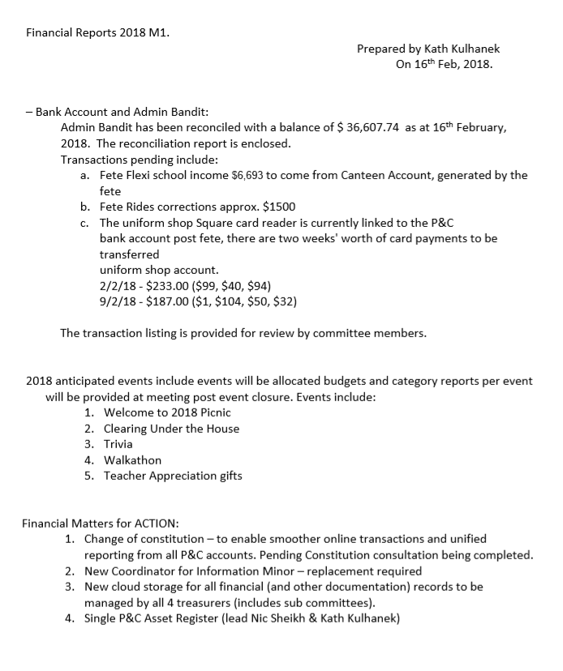

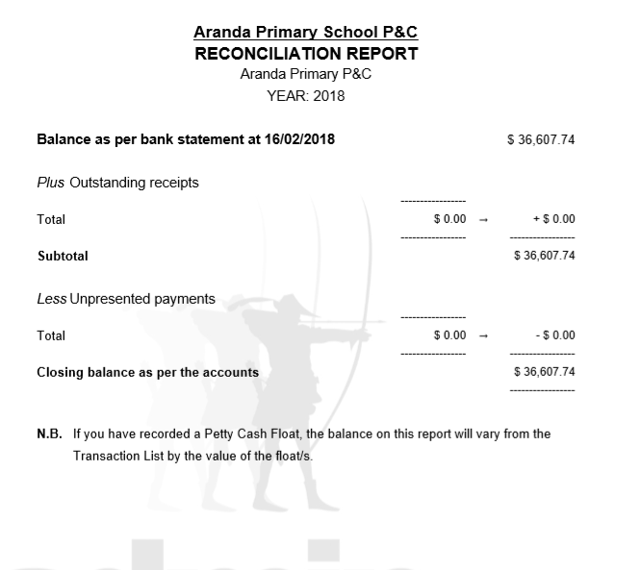

Appendix C – Music and Arts Program Treasurer’s Report

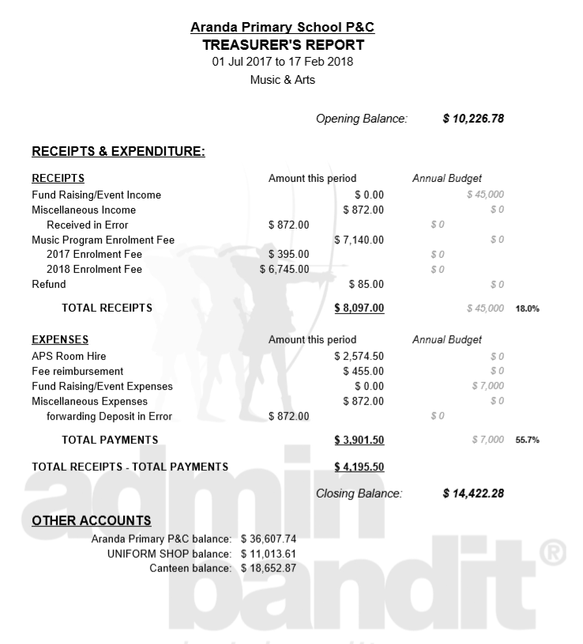

Appendix D – Uniform Shop Report

Notes for P&C meeting on 21st February 2018

Bank Account and Admin Bandit
- Felix has advised that P&C Treasure Kath is now generating all the AdminBandit subcommittee reports (thanks Kath!)

Uniform Shop – Term 1, 2018
- Staff update: we have three new volunteers, but have lost three volunteers, two of whom were very experienced. We plan to advertise again in the newsletter, and through parent class reps now we’re getting settled into the new school year
- Electronic payments: setting up the Paypal machine (bought by the P&C for use at the fetes) for use in the uniform shop is more involved than previously thought, however we are slowly progressing. Due to the lengthy process, I have been using a Square card reader I purchased for the fete. But it is set up with the P&C bank account, not the uniform shop bank account. I am trying to get this resolved, but again, it is complicated. We have been taking card payments each week so far this year. Kath – are you and Felix happy for us to continue to use the Square card reader (and therefore to transfer amounts between bank accounts) until the Paypal machine is set up?
- Opening the Friday before Term 1 of 2018: we went ahead and opened up the Friday before Term 1 started. It was successful. Alex Kingham asked if we were going to be open on the Monday for the new kindergarten students. We weren’t able to this year, but could consider it for next year.
- Price increase request: Diana has asked if the price of the summer school dress could be increased to $45. Currently $40. Diana to advise reasons for increase.

Lucy Coffey & Diana Godwin Felix Andrews
Uniform Shop Coordinators Uniform Shop Treasurer

